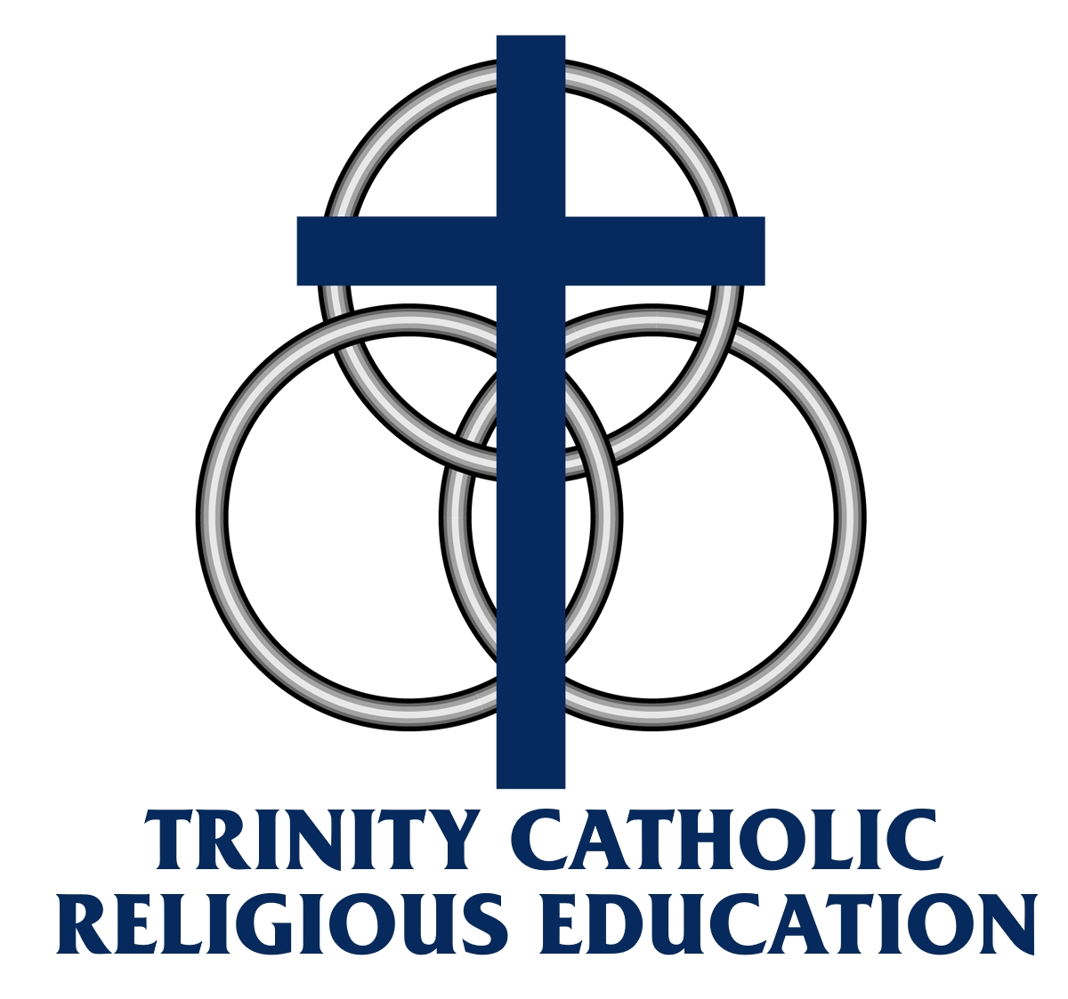

Religion Education Handbook
2022-23

In our school, every day, we learn, love, and pray.

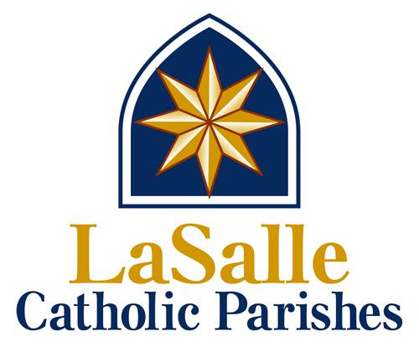

Table of Contents

Religious Education Program 1
Contact Information 2
Class-Sessions (time) 2
Program-Registration Fee 2
Staff 3
Grade Level Assignment 3
Location 4
Drop-Off / Pick-Up Procedure 4
Dress Code 4
School and Classroom Expectations and Guidelines: 5
Attendance Requirements 5
Curriculum 6
Assessment 6
Discipline Policy 7
Communication (RenWeb/FACTS) 9
Safe Environment Training 10

Religious Education Program
LaSalle Catholic Parishes/Trinity Catholic Academy provides a diocesan-approved faith formation curriculum for all students, grades 1-8, who are members of LaSalle Catholic Parishes and attend public schools. Students in grade 2 will receive preparation for the Sacraments of First Reconciliation and First Holy Communion; grade 8 will receive preparation for the Sacrament of Confirmation.

Contact Information
School Phone: 815-223-8523
School Address: 650 4th Street, La Salle, IL 61301
School Email: tcasaints@lasallecatholic.org
Parish Office: 815-223-0641
LaSalle Catholic Parishes Website: www.lasallecatholic.org
Deb Myers: dmyers@lasallecatholic.org
Father Otto: frotto@lasallecatholic.org
Father Pica: frpica@lasallecatholic.org

Class-Sessions (time)
Religion Education classes will begin Wednesday, August 24, 2022 through Wednesday, May 17 , 2023. Each session will begin promptly at 4 P.M. and dismiss at 5 P.M. Calendar is subject to change.

Note: Visit parish website for detailed calendar..

Program-Registration Fee
Our catechetical program at TCA is unique. All classes are taught by professionally licensed teachers trained and formed by Diocesan programs using the best curriculums available. We are striving to dedicate more and more resources to our young students who attend public schools during the day. The RE fees do not cover the cost of this education, but they do help make the program possible. If your family has difficulty with the fees, please complete the Tuition Assistance form (available on the website or at the parish) and we will do all we can to help. Students will not be allowed to attend classes if the fees for the current semester are not paid directly or through tuition assistance. The program fees are the same as last year:

- First semester education fee: $100 per family. Due: August 22, 2022.
- 2nd semester education fee: $100 per family. Due Wednesday, January 11 , 2023

- Each family will receive an invoice in the mail as a reminder.

- First Communion (2nd grade) fee: $35 per child. Due:August 22, 2022.
- Confirmation (8th grade) fee: $35 per child Due on registration weekend, August 22, 2022.

All payments should be made payable to: Trinity Catholic Academy Religion Education. Payments can be dropped off at the school office during regular school hours or the parish office. Financial assistance is available for qualifying families.

Staff
GRADE LEVEL | TEACHER NAME
1 | Kathy Brayton
2 | Gina Baker
3 | Kori Suarez
4 | Carlie Kowalski
5 | Mike Bacidore
6 | Dominic Giacobazzi
7 | Alex Dittmer
8 | Father Tom/Fr. Pica

Grade Level Assignment
Typically, our RE students will be assigned to the grade level they hold at their public school. There are some exceptions: Sacramental preparation for First Communion (2nd grade) and Confirmation (8th grade) are two-year programs. That is, one cannot begin the 2nd grade without completing the 1st grade nor begin 8th grade without successfully completing 7th grade.

If a student is in 2nd or 8th grade in school, but is just now beginning sacramental preparation, he or she will begin class in 1st or 7th grade respectively.

Those who begin RE after 2nd grade, but without having made their First Communion, will continue in their assigned public school grade. They will attend a series of additional RCIC (Rite of Christian Initiation of Children) classes in the spring to prepare to make their First Communion.

Those who are in High School, but without having made their Confirmation, will be invited to attend the RCIA (Rite of Christian Initiation of Adults) classes at the parish and will be Confirmed on the Easter Vigil.

First Communion (2nd Grade) and Confirmation (8th) years require successfully completing the previous level’s program (1st grade and 7th grade, respectively).

Location
All classes will be located at the main campus of TCA (4th and Gooding/Marquette). Grades 1-3 are located in the lower level. Grades 4-8 are located on the main floor of the building. Everyone will enter and exit through the main entrance. At 4 PM, the doors will lock and anyone entering the building must use the buzzer for permission to enter the building

Drop-Off / Pick-Up Procedure
Drop-Off Time: 3:50 P.M. (Students will not be allowed in the building before 3:50 PM).

Traffic will be directed in a one-way pattern. All traffic must enter 4th Street at Gooding Street and exit at Marquette Street.

PLEASE: DO NOT ALLOW YOUR CHILDREN TO CROSS 4TH STREET IN THE PATH OF ONCOMING TRAFFIC!

Vehicles can park in any parking area excluding parking spaces in front of the school on 4th Street between Gooding and Marquette. To ensure the safety of dismissed students, both streets will be blocked with barricades beginning at 4:45 until all students have been dismissed and barricades are removed.

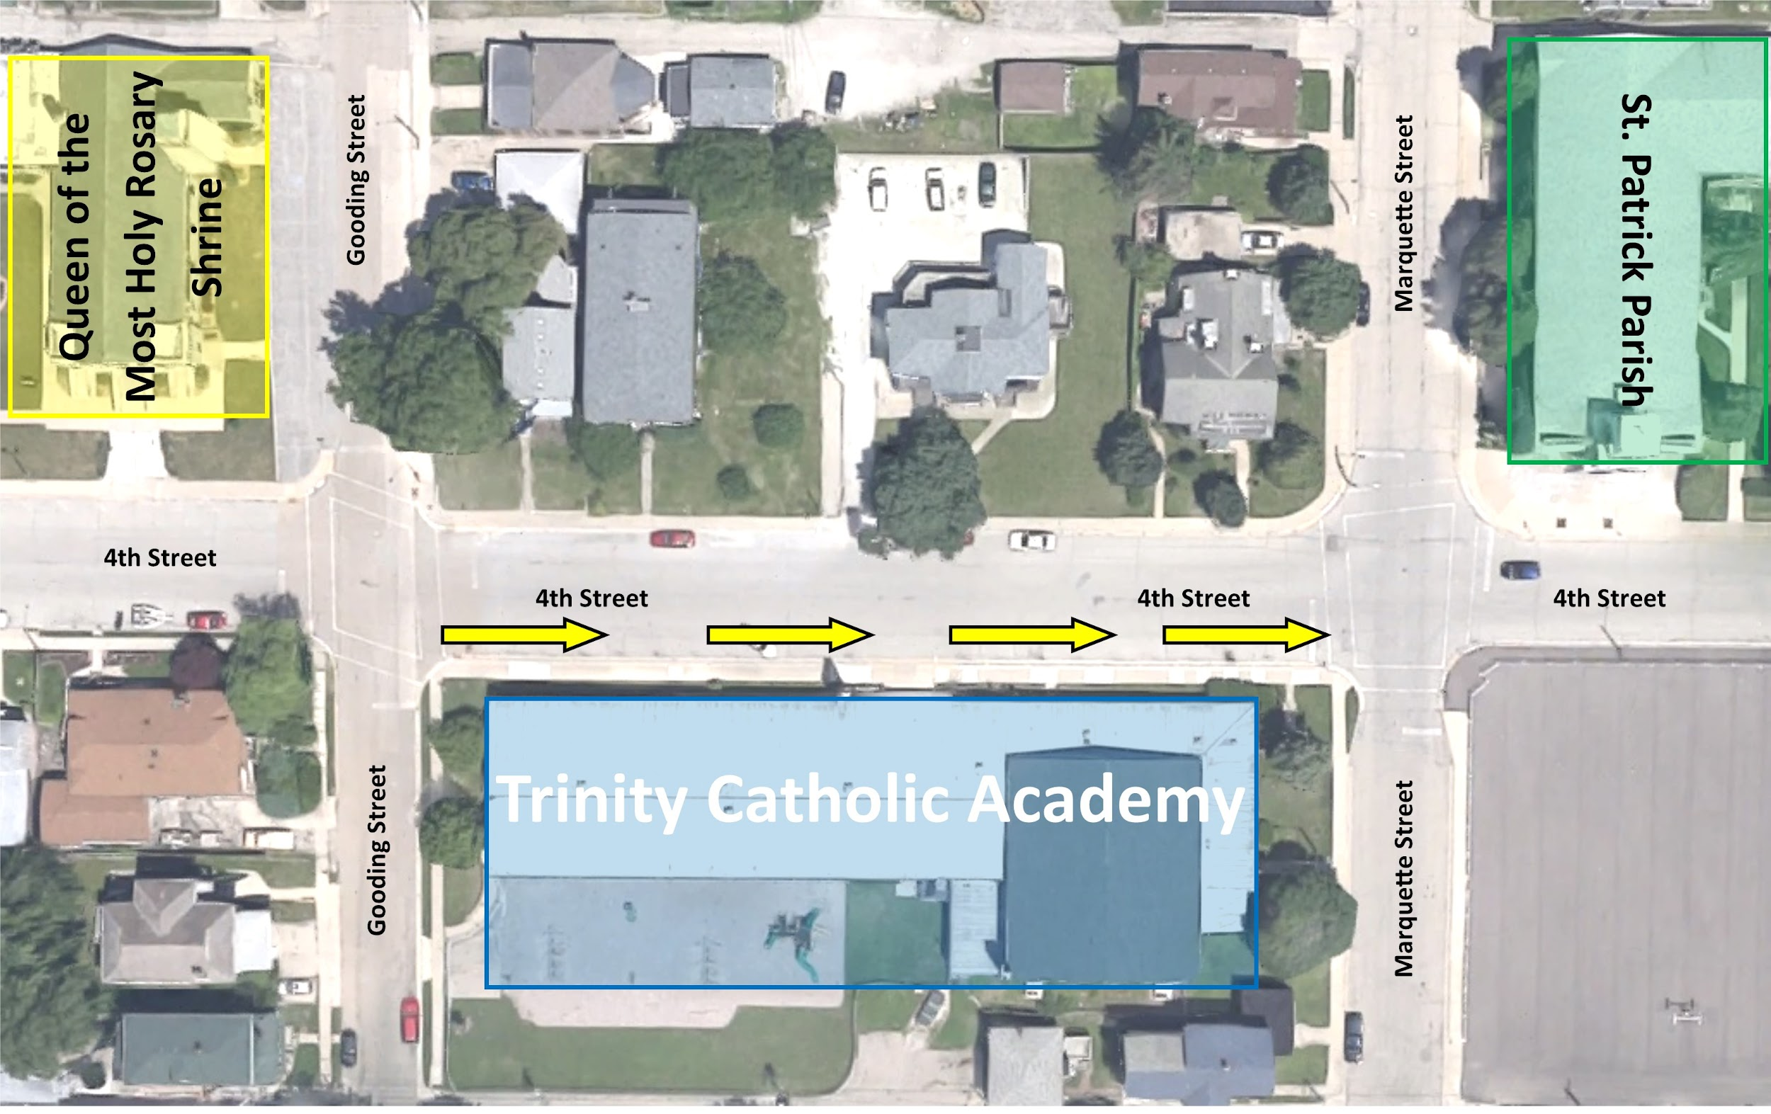

Dress Code
The dress code will be followed for every session beginning with the first session of the year. At TCA, we believe students and staff should modestly dress for success. The following code will be required:
Shirts: Shirts must be a solid color with no offensive logos or slogans.
Pants: Blue/black jeans or khaki will be allowed. Rips or tears will not be allowed on pants. Athletic wear (ex. yoga, spandex, and leggings with see-thru inserts) will not be allowed. Knee length shorts are allowed but are not allowed on Mass days.
Shoes: Standard style shoes or clean athletic shoes are to be worn. If shoes require laces, laces must be worn and tied. For safety, flip-flops or strapless shoes are not allowed.
Sweatshirts: Hoodies will not be worn in class.

School and Classroom Expectations and Guidelines:
- Everyone has the right to come to school and have a good day!
- Students are required to follow and respect each teacher’s classroom expectations.
- Personal cell phones or other personal electronic equipment are to be powered off in class. Teachers have the authority to collect the devices before class and return them at the end of class.
- Students are not allowed to leave the classroom without a teacher’s permission
- Parents will be notified by the program staff regarding unacceptable student behavior.

Attendance Requirements
Trinity Catholic Academy Religious Education Program has attendance and tardy requirements to avoid loss of instruction time in the classroom. Students are required to be in their assigned seats at the beginning of class, 4 P.M. Excused absences must be reported to the school by a parent/guardian. The following policy will be enforced:
Documented attendance: Teachers will record attendance for each class using RenWeb/FACTS.

Tardy: Students will be allowed 3 unexcused tardy arrivals per semester. A student is considered tardy if they are not in their classroom at 4 PM. If a student accumulates 3 tardy arrivals, a student will no longer be allowed to continue in the program. Parents will be notified by letter that a child is no longer a student in the RE program for the current school year.

Absence: Students with 3 unexcused absences per semester will not be allowed to continue in the program. Students must attend a minimum of 45 minutes to be considered a full class session.

Excused Absences must be called into the school office before the beginning of class. These absences would typically include things such as sickness, doctor’s appointment, or family emergency. Sporting events, practices, and games as well as other school co-curriculars are not excused absences. Instruction in the Faith requires priority over these activities. If your child needs a note from the school or priest for this religious exemption, please let us know, we will be happy to help!

NOTE: IF A STUDENT IS REMOVED FROM THE PROGRAM DUE TO TARDINESS OR UNEXCUSED ABSENCES, PAID FEES WILL NOT BE REIMBURSED. STUDENTS WILL NOT BE ADVANCED TO THE NEXT GRADE LEVEL.

Curriculum
Grades 1-8 will receive instruction with a variety of differentiated resources. To align the program with full-time TCA students, grades 1-7 will use Finding God-Loyola Press as the required textbook. Grade 8 will receive instruction from the Chosen Series-Ascension Press.

Students will also attend Mass for Holy Days of Obligation, as well as, scheduled times for the Sacrament of Reconciliation.

IMPORTANT: First Communion (2nd Grade) and Confirmation (8th) years require successfully completing the 1st grade and 7th grade programs.

Assessment
To indicate active participation of the students and families, teachers will use a variety of formal and informal assessments throughout the course of the program. Examples may include: homework, quizzes, tests, essays, memorized prayers, and grade level knowledge of the Catholic Faith. Most likely, students will be required to complete some form of assessment each week at home or in class.

Confirmation candidates in 8th grade must complete the summer/fall catechism class, a service project, a saint report, and attend the Confirmation retreat.

Students will also receive a progress report at the end of each grading quarter. Parents can also access RenWeb/FACTS at any time, to view a student’s progress. If a student is failing, the parents will be notified. Student removal from the program may be considered if a student is failing.

Discipline Policy
Our students, through their personal conduct, should reflect Jesus and his teachings. On those occasions when this attitude or behavior is not evident, the following steps will be taken to guide the students in Christian behavior.

As professionally prepared persons, the teachers, staff and volunteers will be expected to use their own methods of disciplining students who behave inappropriately in accordance with Diocesan and TCA policies. This approach should always be of a consistent and positive nature. An appropriate consequence, which relates to the misbehavior will be given by the teacher and seen to completion by the student.

Discipline – Jurisdiction: Trinity Catholic Academy has jurisdiction over its students during the regular school day. The school’s jurisdiction includes any school related activity, regardless of time and location.

Acts of Disobedience
The following are considered serious acts of misbehavior and could possibly result in the student receiving after class detentions or being referred to the principal for assessment and resolution of the situation. Prior to completion of detention, parents/guardians will be notified.
- Disruptive behavior in the churches, classroom, on or near school property, or at school related functions.
- Cheating or dishonesty on any academic work.
- Possession of, use of, or distribution of alcohol, cigarettes, drugs, or any other substance or weapon which is otherwise unlawful for a student to possess, use, or distribute. (See Diocesan Weapons Policy D150 Appendix D, CDOP.ORG)
- Fighting or assaulting any person.
- Theft or intentional damage to or destruction of school property, or personal property of others.
- Other acts which directly or indirectly jeopardize the physical or psychological health, safety, and welfare of self and others at school.
- Insubordination to school personnel.
- Verbal abuse or use of profanity, obscenity, or obscene gestures.
- Intimidating or attempting to intimidate school personnel, staff or students. (See Diocesan Harassment Policy C 401 Appendix E, CDOP.ORG)
- Use of school computers to obtain, copy and/or disseminate inappropriate materials, including, but not limited to pornographic, violent or hate-inspiring topics.
- Any activity that is considered by the administration to interfere with the best interests of the school, its mission, and/or its students, faculty and staff.
- Gang related activities: display or possession of gang related paraphernalia, drawing gang graffiti, and using signs and signals in furtherance of gang activity.
- Bullying (See Diocesan Bullying Policy D 147 Appendix F CDOP.ORG)

Search and Seizure: Searches of students will be conducted according to the reasonable person doctrine of tort law. Reasonable cause will be held to exist when an administrator has reliable knowledge about the whereabouts of illegal or dangerous material on campus. Reasonable cause might include anonymous phone calls or hearsay.

Harassment: In the caring and supportive atmosphere of Trinity Catholic Academy, we strive to honor the dignity of one another with respect and courtesy. If we fail to give this respect to one another, our Catholic faith calls us to give witness to the Gospel and seek truth and justice in restoring the bond that has been broken within this community.
(See Diocesan Harassment Policy Appendix B, CDOP.ORG)

All faculty, staff, and students of Trinity Catholic Academy should have the reasonable expectation of working and interacting in an environment where they receive respect and are surrounded by Christian values. Harassment of any type – verbal, physical, visual, or sexual is opposed and will not be tolerated. The term “harassment” includes, but is not limited to, slurs, jokes, or any other form of verbal, graphic, or physical contact which reflects adversely on an individual’s race, color, sex, religion, national origin, citizenship, age marital status, veteran status, or mental, physical, or academic handicap. Harassment of any person on school grounds or at any school-related function or by any employee while acting as a representative of this institution is not acceptable. Any individual judged harassing another will be subject to appropriate disciplinary action.

Engagement in online blogs such as, but not limited to, Facebook, Twitter, Instagram, Snapchat, etc. may result in disciplinary actions if the content of the student’s blog includes defamatory comments regarding the school, the faculty, other students or the parish.

What to Do If You Are Harassed:
- Students should tell the person harassing them what their feelings are and ask him or her to stop.
- If this is too difficult to do alone, the student should seek help from a teacher, parent, friend, or the principal of the school
- If the behavior is repeated or is a major offense, report it to a teacher or the principal.
- After an investigation that proves the report to be true, the harasser will be subject to suspension or expulsion
- A written record of the harassment will be recorded and put into the student’s file.
(See Diocesan Harassment Policy C-401 Appendix E, CDOP.ORG)

Bullying - All elementary and secondary schools of the Diocese shall actively seek to provide a supportive, caring environment that is safe from all forms of intimidation, including bullying. Bullying is repeated behavior involving a deliberate, conscious intent to hurt, threaten, frighten, or humiliate someone. It may include physical and/or verbal intimidation or assault; extortion or taking belongings; oral or written threats; outrageous teasing, mocking, taunting, put downs or name-calling; threatening looks, gestures, or actions; cruel rumors; suggestive comments; false accusations, and/or social isolation. Bullying behavior shall not be tolerated in any form at school or school-sponsored programs and activities. (See Diocesan Bullying Policy D-147 as Appendix F, CDOP.ORG)

General Guidelines for Assessing Discipline Penalties
When imposing discipline, school personnel will adhere to the following guidelines:
- Discipline will be administered when necessary to protect students, school employees, or property and to maintain essential order and discipline.
- Students will be treated in a fair and equitable manner. Discipline will be based upon a careful assessment of the circumstances of each case. Factors for consideration will include:
- seriousness of the offense
- student’s age
- frequency of misconduct
- student’s attitude
- potential effect of the misconduct on the school environment
- School administration has final authority

Permanent Dismissal As soon as it becomes evident that expulsion of a particular student is necessary; the principal will consult with the pastor and advise the parents or guardians of the child and the child’s teacher(s).

Communication (RenWeb/FACTS)
In order to have access to RenWeb.com, parents or guardians are required to have an email account. Most communication with the school staff and teachers regarding a child’s grades, progress reports, discipline, assignments, announcements, and any relevant information regarding the program will be through RenWeb. Students’ parents will be given a Renweb account.

Safe Environment Training
Any adult acting as a teacher’s assistant or a volunteer is required to complete a Safe Environment Training Course and background check. The course is offered to all parents/guardians through LaSalle Catholic Parishes. Please contact the school or parish office if you have any questions. Diocesan volunteers can take the online training for Safe Environment on the following website: http://peoria.cngconnecct.org/
Please follow the specific instructions to register an account and complete the online training video. Please be sure to print a copy of your certificate of completion.

